Job Description:

Youth Hub Coordinator

(Ludlow Archdeaconry)

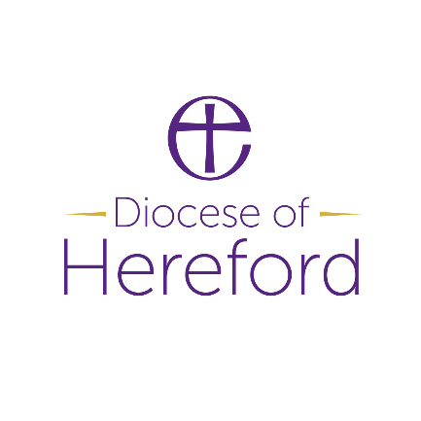

**Job Purpose:**

To enable effective delivery and growth of our existing Youth Hub across the Clun Forest and Pontesbury deaneries and to support local leaders to identify new Youth Hub areas and support their development.

To work as part of a diocesan-wide team, to ensure effective local research and evaluation and identify learning opportunities in collaboration with the Church of England Vision & Strategy Team.

Youth Hubs will have a focus on:

* Reaching young people with the Gospel
* Developing new young active disciples
* Forming of New Worshipping Communities
* Growing Young Leaders
* Developing new volunteer leaders and teams

**Dimensions:**

Supporting the development of the Youth Hubs through stakeholder engagement, the development of local leadership teams and local research and evaluation.

**Accountabilities:**

* Work with key stake holders within the Youth Hubs, supporting the development and communication of the vision for a local Youth Hub. This will include creating a local stakeholder engagement plan for each hub in consultation with the Lead Intergenerational Missioner and Communications Director.
* Manage the Youth Pioneers leading Youth Hubs within the Ludlow Archdeaconry.
* Work with clergy, PCCs and local congregations, strengthening local and diocesan relationships to enable an overall vision for mission and growth within the wider Youth Hub areas, leading to a ‘hub and spoke model’ with connected youth ministry in villages. With local leaders, identify current faith pathways and opportunities for further development.
* Work alongside Missional Youth Church Network to prayerfully build understanding, team and vision for the Learning Journey and Missional Youth Church within a Hub area and train leaders in youth evangelism and mission.
* Liaise with diocesan colleagues to ensure effective local evaluation and research.
* Supported by the diocesan Ministry and Mission Team and the Church of England Vision & Strategy Team, create learning events to share good practice and develop a replicable model of dispersed rural youth work.

* Identify and signpost/facilitate training that will enable Hub areas to develop key skills, understanding and practice in Youth Ministry, Best Practice, Safeguarding, Mission and Discipleship. Have a working knowledge of training and support offered through diocesan provision and with key partners (e.g. Safeguarding, Comms, Youthscape, Missional Youth Church Network, Church Army etc.) in order to facilitate this.
* Support the start-up and ongoing development of new mission opportunities, identified through the stakeholder engagement and vision, enabling local volunteer teams.
* Work alongside employed workers and leaders connected to the Youth Hubs, to develop long-term vision and sustainability.
* Report on progress and take part in and feedback to the Ministry and Mission Team meetings as appropriate.
* Working with the Diocesan Comms Team, Lead Intergenerational Missioner/Programme Manager, and Ministry and Mission Team, identify opportunities for developing diocesan-wide communications and good-news stories/shared learning.
* With the support of the Line Manager, to set aside time for reflection and personal faith and professional development as appropriate.

Occupational Requirement  
Given the nature of the role and its central place in promoting and communicating the aims of the Diocese and within the provisions of the Equality Act 2010 there is an Occupational Requirement that the post holder be a committed Christian

**DBS**  
Given the nature of the role an enhanced DBS check is required.

**Special Features**

**Relationships:**

* Lead Intergenerational Missioner
* Youth Hub Co-ordinator (Hereford Archdeaconry)
* Programme Manager
* Youth Hubs Safeguarding Officer
* Youth Hubs Communications Officer
* Ministry and Mission Team
* Intergenerational Church Enabler
* Leaders and Employed Workers within Youth Hub areas
* Missional Youth Church Network
* Education Department

**Organisation Chart**

**Qualifications & Experience**

|  |  |  |
| --- | --- | --- |
| **AREA** | **ESSENTIAL** | **DESIRABLE** |
| **Knowledge/ Qualifications/ Membership of Professional bodies (or equivalent)** | Have a recognised qualification linked to children/families/youth /intergenerational work. | A recognised qualification in Theology  Have a recognised qualification in training or educating adults. |
| **Type of Experience required** | Relevant experience within intergenerational, younger generations and missional contexts.  Experience of motivating, supporting and managing volunteers and/or paid workers.  Experience of training, coaching and mentoring adults.  Technological competency in the use of everyday computer programmes. | Experience of work with children and families within a rural church and / or parish setting.  Experience of working within school structures.  Experience with employment situations, non-managerial supervisions. |

Intergenerational Missioner/Church Enabler

Other members of Mission and Ministry Team

Mission Enabler - Society

Mission Enabler - Environment

Lead Intergenerational Missioner

**Youth Hub**

**Co-ordinators**

Director Of Mission and Ministry

**Competencies**

|  |  |
| --- | --- |
| **ESSENTIAL** | **DESIRABLE** |
| Holder of a strong Christian faith with a passion to share the Gospel, particularly with younger generations, that they may have the opportunity to grow in faith.  Excellent interpersonal skills, open and collaborative. Able to build strong working relationships with ability to relate to a range of parishes and people in differing contexts and stages in their journeys of ministry and discipleship:  Leadership abilities, with capability to inspire and encourage others.  An ability to think theologically and enable others to do so.  Team-working skills and an amicable attitude when working on other’s projects.  Willingness to work ecumenically and with external organisations.  Able to manage a complex workload.  Holds a full driving license and access to a car.  A commitment to their own personal, spiritual and professional vocation and development – and the ability to grow that in others.  Ability to be strategic, creative and imaginative in development work and in training.  A good understanding (or ability to acquire understanding) of the traditions, values, structures and practices of the Church of England.  An understanding of, and sensitivity to, the changes in social, cultural and spiritual influences over the generations. | An active member of the Anglican Communion. |

|  |  |
| --- | --- |
| **Agreed: Job Holder**: |  |
| **Agreed: Line Manager**: |  |
| **Date:** |  |